**Motor Claim Administration System**

**(MCAS)**

**Step1. Receive Build Request-**

We receive an e-mail when build needs to be applied (For Local UAT build is applied on daily basis. For Singapore UAT build is applied every week). After merging the related change sets of those issues which need to be move on higher environment. Below attachment is sample email.



**Step2.**  **Query Creation And Execution-**

Open Visual studio -> Go to Team Explorer -> Create New Query as follows. We find the items whose status is **‘Resolved and To Be Reviewed’**.

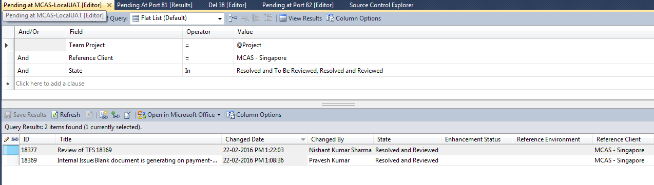

After Executing this query got sorted list of TFS ID, which satisfy above query conditions. And then arrange these TFS IDs in ascending order.

**Step3.**  **Merging Change set At Target Branch-**

Get the latest version of the branch. Merge all change sets to Local UAT branch.

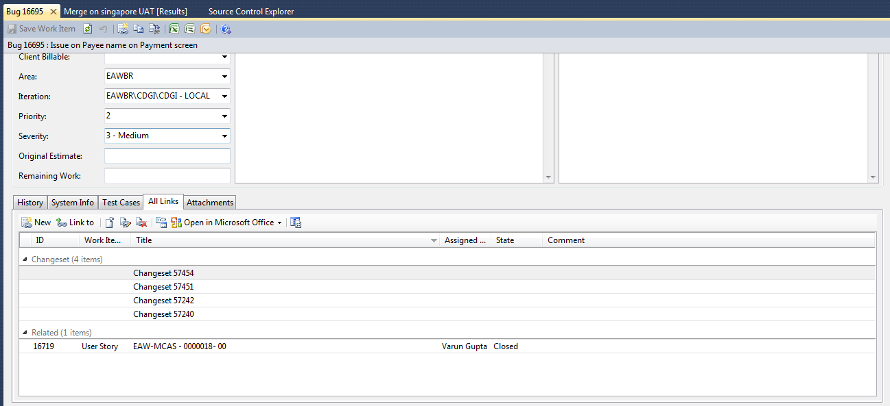

Select a change set number in ascending order and track it on Source Control Explorer.

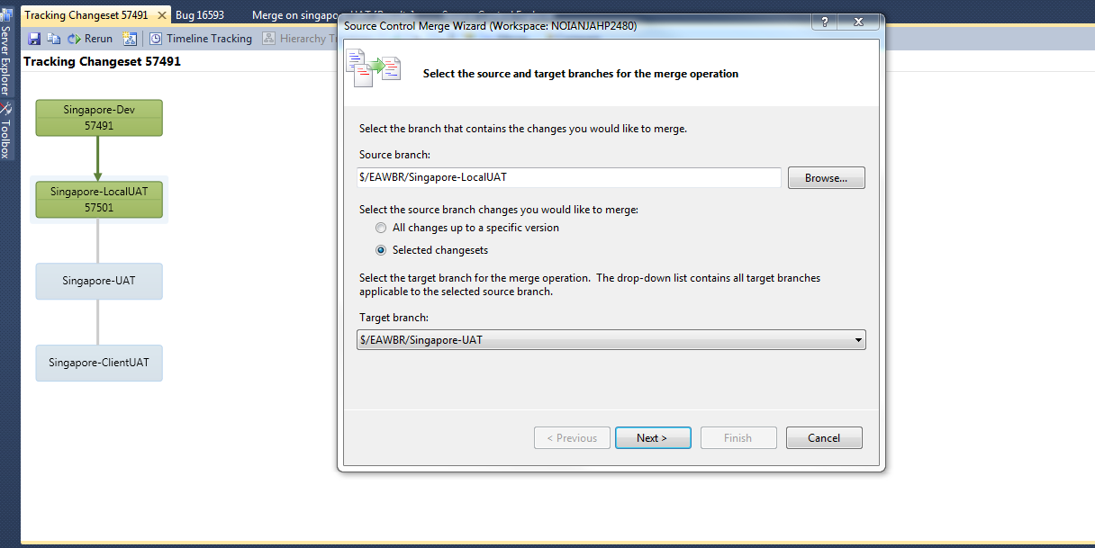

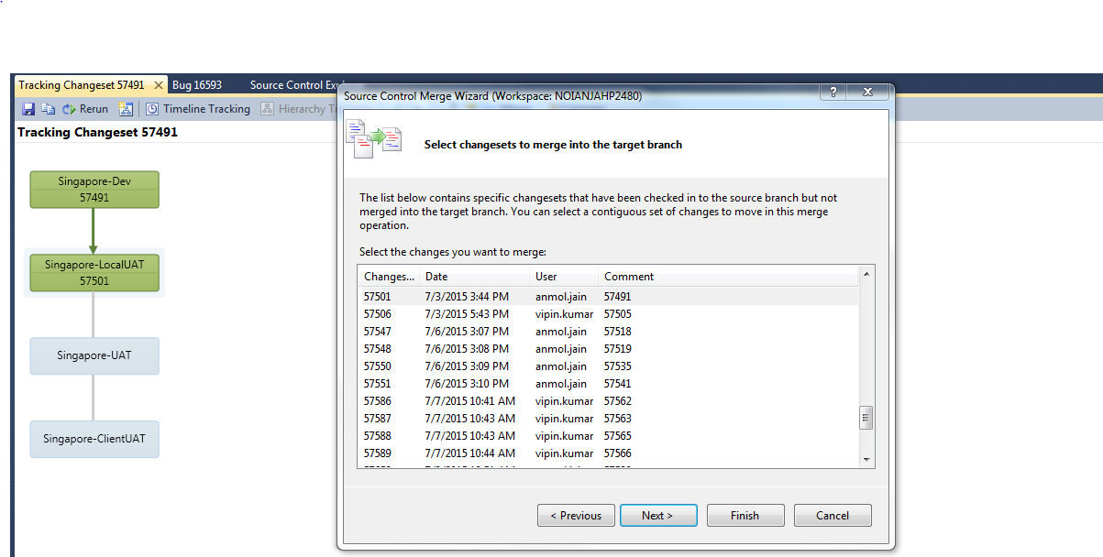

**Perform Final Merge operation-**

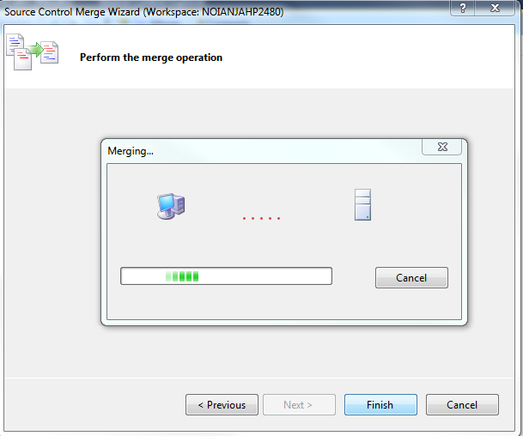

**Step4. Check in Process At Target Branch.**

After merging operation, CheckIn on target branch and perform check In process

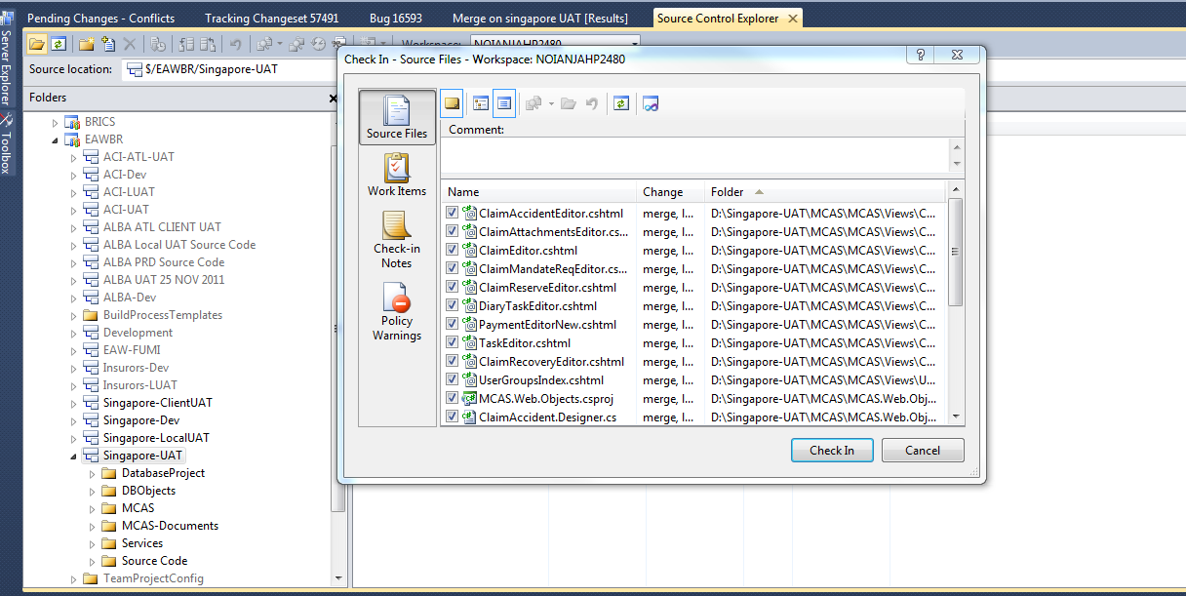

**Step5**. **Patch Preparation.**

**Code Deployment**

For code deployment process, access hosting environment 192.168.91.36

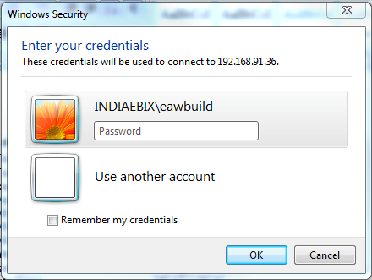

Code Build

**↓**

Code Rebuild

**↓**

Publish

**Code Build And Rebuild-** Take latest of branch. View solution file of MCAS then perform build operation.

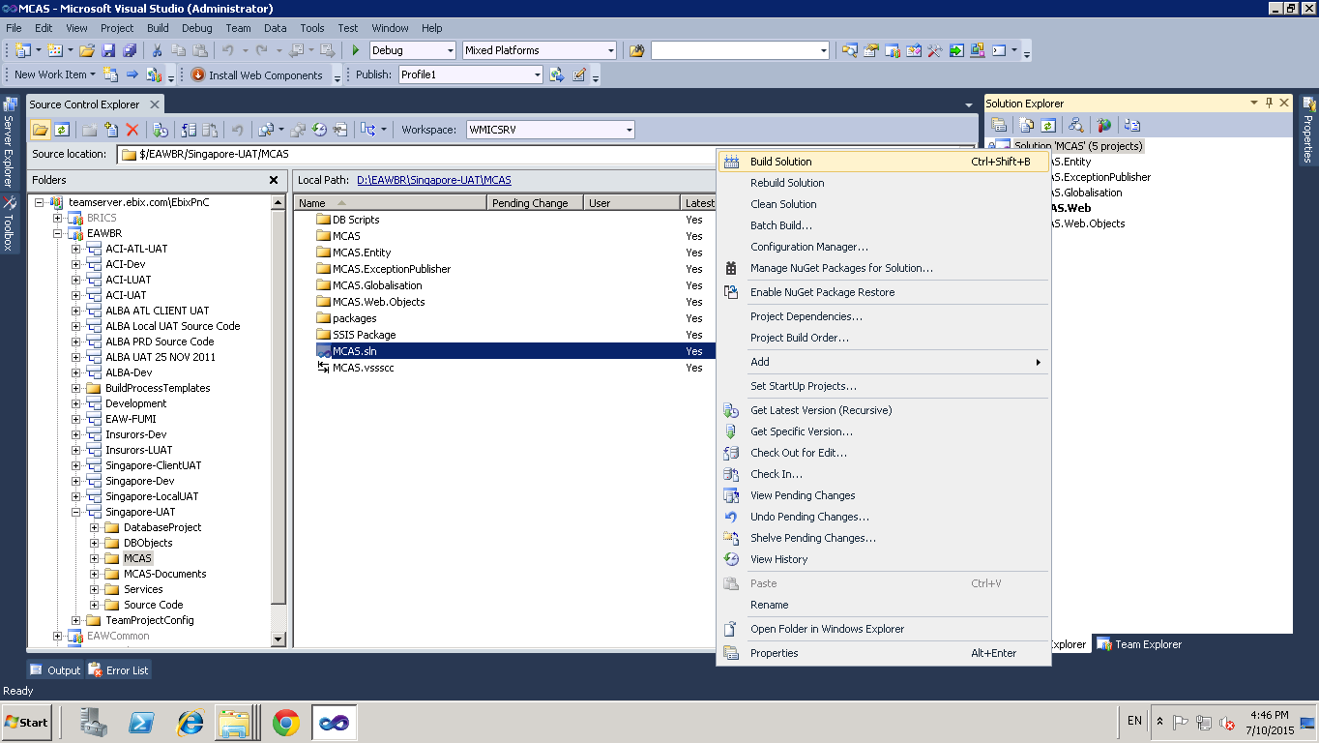

**Publish Code-**

After build and rebuild operation, publish the code on location:

**“D:\MCAS PUBLISH FOLDER\Singapore-LocalUAT\ MCAS.Web”**

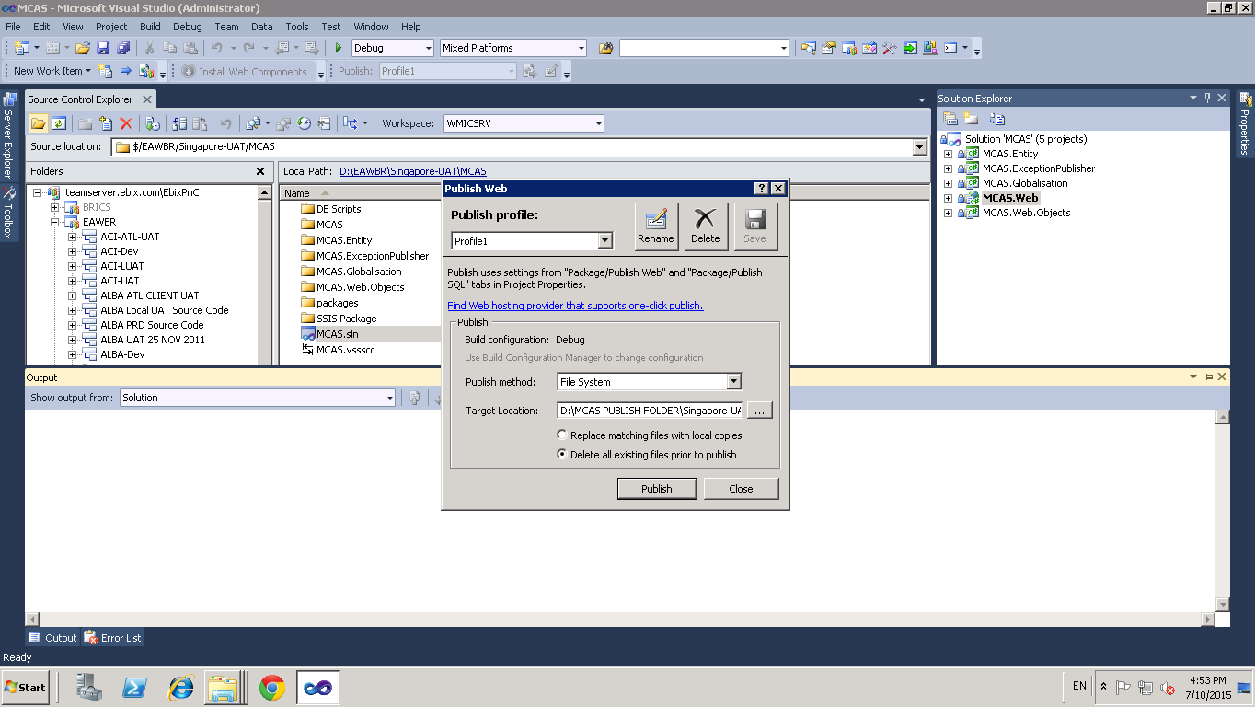

**Access Host Machine-** For Deployment of code and database patch, access the Web Server Host Machine.

**Web Server (IIS) Hosted At-** 192.168.91.18

Site Name- MCAS LOCAL (For Singapore Local UAT)

Site Name- MCAS (For Singapore UAT)

After publishing the code,

Copy code from MCAS.Webfolderfrom machine 36and paste at “**E:\MCAS LOCAL UAT\”** on machine .18

**Database Deployment**

For Data deployment process, firstly deploy the data at local.

Build Database

**↓**

Deploy Database

Create database patch (including DDL and DML) on shared drive “192.168.91.17” with folder name as ‘dd-mm-yyyy Vs x.x’

**Shared drive path-**

**\\192.168.91.17\Ebix-Advantage\Configuration Management\ EAW-MCAS\Pending to Singapore-LocalUAT\**

First we execute DDL scripts on the database and then start deployment for Database including DML, functions, views, procedures.